Optimization

The Visual C++ Toolkit 2003 includes an optimizing C++ compiler. Most of the switches are fairly straightforward and have been in the Visual C++ product for many versions, although two are more recent and can produce dramatic speed improvements without any need to rewrite code. These are /GL, “Whole Program Optimization”, and /G7, which emits code optimized for the Pentium 4 or AMD Athlon. A related option is /arch:SSE2, which emits code targeted at the SSE2 registers and instructions.

The sample code runs three tests. They are:
- Call functions that are inline candidates
- Perform a large number of floating point multiplications and additions
- Perform a large number of integer multiplications and additions

Whole Program Optimization

The sample code defines two very similar functions, called Add() and DisplayAdd(). DisplayAdd() writes to the screen and is unlikely to be inlined as a result:

void DisplayAdd(int a, int b)
{
cout << a << " + " << b << " = " << a + b << endl;
cout << "Return address from " << __FUNCTION__
<< " " << _ReturnAddress() << endl;
}

The _ReturnAddress function is an intrinsic that reports where control will return. It’s useful for identifying inlined functions.

Add() is declared in gl-g7.cpp, along with a global it sets:

void* inlineReturnAddress; // set in Add()
int Add(int a, int b); // implementation in module.cpp

The implementation is in module.cpp:

int Add(int a, int b)
{
inlineReturnAddress = _ReturnAddress();
return a+b;
}

To compile this program without Whole Program Optimization, use this command line:

cl /O2 /ML /EHsc GL-G7.cpp module.cpp

To run Test 1, use this command:

gl-g7 1

You should see output similar to this (the numerical addresses will vary):

1 + 2 = 3
Return address from DisplayAdd 00401D0A
1 + 2 = 3
Return address from Add 00401D13
Return address from Test1 00402125

The return address from Add() is not the same as from Test1(): Add() was not inlined.

Now recompile with /GL:

cl /O2 /ML /EHsc /GL GL-G7.cpp module.cpp

Run Test 1 again and you should see output like this:

1 + 2 = 3
Return address from DisplayAdd 00401242
1 + 2 = 3
Return address from Add 0040179F
Return address from Test1 0040179F

Now the return address from Add() and Test1() are the same: Add() was inlined within Test1() even though its code came from another file.

Optimize code for the Intel Pentium 4 or AMD Athlon

The G7 option is new in Visual Studio .NET 2003 and produces code that is optimized for the Pentium 4 or the AMD Athlon. It does this by choosing different instructions than it otherwise would. The best performance improvement is seen in routines that multiply integers, especially multiplying an integer by a constant known at compile time.

Test 2 demonstrates the speed improvements that are possible:

#define INT_ARRAY_LEN 100000
int intarray[INT_ARRAY_LEN];
int intCalculate()
{
int total = 0;

for (int i = 1; i < INT_ARRAY_LEN; i++)
{
total += intarray[i-1]*7;
}

return total;
}

void Test2()
{
int var1 = 2;
int i;

for (i = 0; i < INT_ARRAY_LEN; i++)
{
intarray[i] = i*5;
var1 += 2;
}

LARGE_INTEGER start, end;
LARGE_INTEGER freq;

SetThreadAffinityMask(GetCurrentThread(), 1);
QueryPerformanceFrequency(&freq);
QueryPerformanceCounter(&start);
double total = 0;

for (i = 0; i < 100000; i++)
{
total += intCalculate();
}

QueryPerformanceCounter(&end);

cout << "Total = " << total << endl;

cout << (end.QuadPart - start.QuadPart)/(double)freq.QuadPart << " seconds" << endl;
}

This code uses some timing functions that are implemented in kernel32.dll, part of Windows. These functions and the data types they use are defined in windows.h. To reduce dependencies in this sample, the functions are prototyped, and the data types are defined, within gl-g7.cpp. QueryPerformanceCounter saves a starting or ending position, and QueryPerformanceFrequency gets a value to divide into the difference between starting and ending, producing an elapsed time in seconds. The call to SetThreadAffinityMask reduces artifacts on multiprocessor machines.

This routine performs a lot of integer multiplication. To compile it without processor-specific instructions, use this command line:

cl /O2 /ML /EHsc GL-G7.cpp module.cpp

To compile it for a Pentium 4 or AMD Athlon machine, use this command line:

cl /O2 /ML /EHsc /G7 GL-G7.cpp module.cpp

To run test 2, use this command line:

gl-g7 2

On a Pentium 4 or AMD Athlon64 machine, the /G7 version runs over 10% faster. This code can be run on a machine without the appropriate chip, but will be slightly slower than the version compiled without /G7.

Streaming SIMD Extensions 2

If you are sure you are building code for a computer that has SSE2 support, e.g. Pentium 4 or AMD Athlon64 machine, you can use the /arch:SSE2 option. This produces code that will not run on other chips, but is much faster, especially for routines with a lot of floating point arithmetic.

Test 3 performs a floating point calculation very similar to Test 2:

#define ARRAY_LEN 10000
double array[ARRAY_LEN];

double Calculate()
{
double total = 0;

for (int i = 1; i < ARRAY_LEN; i++)
{
total += array[i-1]*array[i];
}

return total;
}

void Test2()
{
double var1 = 2;
int i;

for (i = 0; i < ARRAY_LEN; i++)
{
array[i] = var1;
var1 += .012;
}

LARGE_INTEGER start, end;
LARGE_INTEGER freq;

SetThreadAffinityMask(GetCurrentThread(), 1);
QueryPerformanceFrequency(&freq);
QueryPerformanceCounter(&start);
double total = 0;

for (i = 0; i < 100000; i++)
{
total += Calculate();
}

QueryPerformanceCounter(&end);

cout << "Total = " << total << endl;

cout << (end.QuadPart - start.QuadPart)/(double)freq.QuadPart << " seconds" << endl;
}

To compile it without processor-specific instructions, use this command line:

cl /O2 /ML /EHsc GL-G7.cpp module.cpp

To compile it for a Pentium 4 or AMD Athlon machine only, use this command line:

cl /O2 /ML /EHsc /G7 /arch:SSE2 GL-G7.cpp module.cpp

To run test 3, use this command line:

gl-g7 3

On a Pentium 4 or AMD Athlon machine, the /G7 /arch:SSE2 version runs about 10% faster. This code cannot be run on a machine without the appropriate chip.

If you have Visual Studio
All these options are available on the Project Properties dialog:

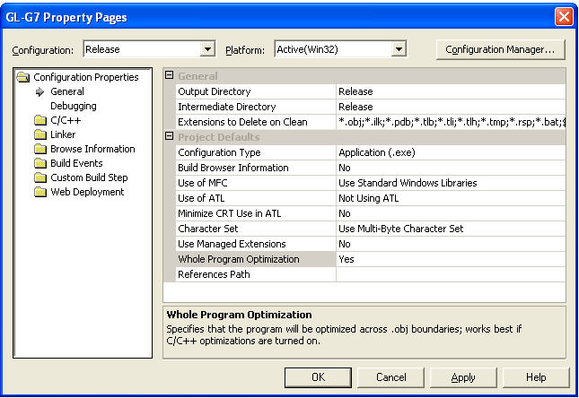

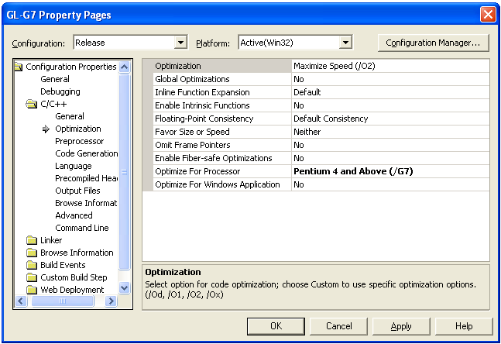

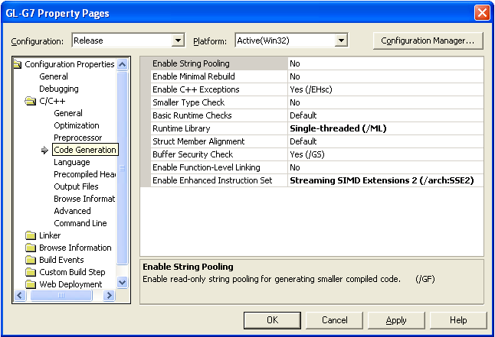

If you want to produce tailored versions for specific chips, you can create a several configurations, each with a different combination of options.

Summary

Different programs respond to optimization in different ways. While the module-by-module optimization is good, adding whole program optimization can make a dramatic improvement. Since you don’t need to change your code to use it, there’s no reason not to.

If most of your user base, or all the performance-sensitive users, have Pentium 4 or AMD Athlon machines, use the /G7 option to produce faster code for these users, knowing that it will be slightly slower for the rest of your users. If you’re going to create specific optimized versions for Pentium 4 or AMD Athlon64 machines, use the /arch:SSE2 option as well for maximum gain.

